Name: Famitha Begum || Email ID:famithabegum418@gmail.com

TESTING APP: Netcom+ Website

1. Feature/Screen Name: Onboarding Screen
Issue Found: Skip page reappears when re-entering the app after first use.
Steps to Reproduce:
- Open the app for the first time.
- Skip the onboarding screen.
- Close and reopen the app.
- Observe that the onboarding screen appears again.
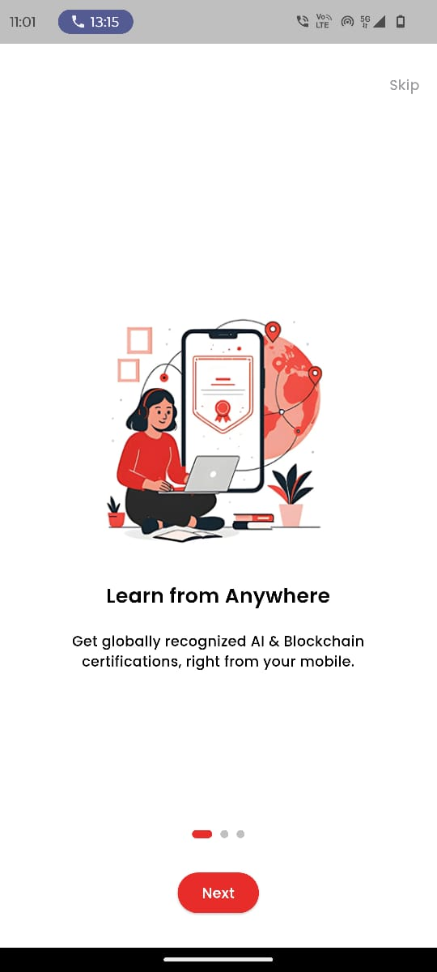
Expected Result: Onboarding screen should appear only during the first launch or after reset, and return users should go directly to the home screen.
Actual Result: Onboarding screen reappears every time the app is opened.
ScreenShot:

2. Feature/Screen Name: Onboarding Screen
Issue Found: List does not scroll when touching outside the radio button area.

Steps to Reproduce:
- Navigate to any screen with a radio button list.
- Try scrolling by touching outside the list area.
- Observe scrolling behavior.
Expected Result: Page should scroll regardless of where the touch occurs, while still allowing radio buttons to be selected only when tapped.
Actual Result: Page does not scroll unless touch is directly on the scroll area.
ScreenShot:

3. Feature/Screen Name: Contact Support Page
Issue Found: No error indication for empty Name and Email fields.
Steps to Reproduce:
- Open Contact Support page.
- Leave Name and Email fields blank.
- Attempt to submit the form.
Expected Result: Real-time validation should display error messages (“Name is required”, “Email is required”) and highlight empty fields until corrected.
Actual Result: Form submits without clear error messages.
ScreenShot:
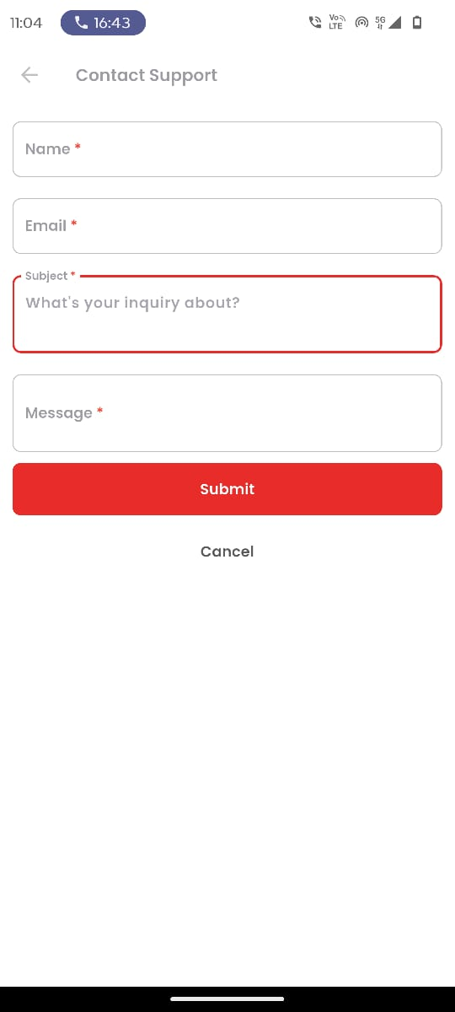

4. Feature/Screen Name: Login Screen
Issue Found: Error message repeats multiple times for invalid email.
Steps to Reproduce:
- Enter an invalid email in any form.
- Observe error message behavior.
Expected Result: Error message should appear only once per invalid entry and disappear after a valid email is entered.
Actual Result: Error message repeatedly triggers for the same invalid input.
ScreenShot:
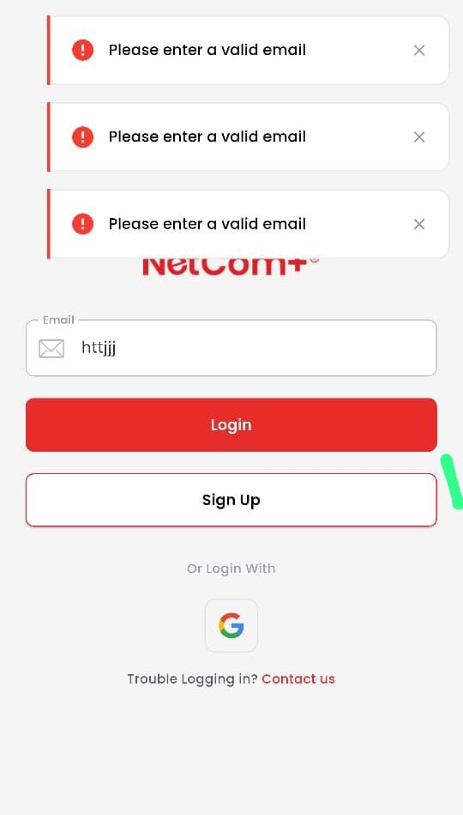

5. Feature/Screen Name: Sign Up Screen
Issue Found: Fields accept blank or invalid characters.
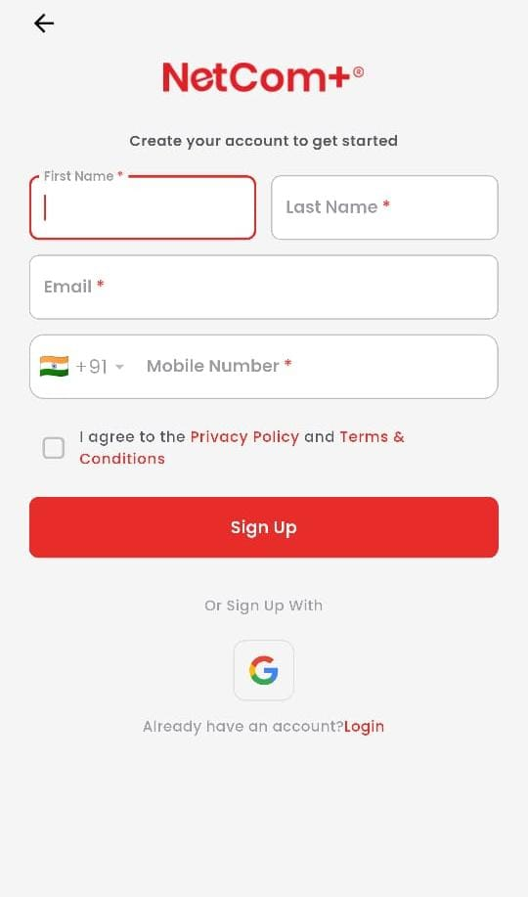
Steps to Reproduce:
- Leave First Name and Last Name fields empty.
- Try to proceed.
Expected Result: Only valid alphabetic characters (with optional spaces, hyphens, or apostrophes) should be accepted; blank entries should show a validation error.
Actual Result: Fields accept empty and invalid characters without warning.
ScreenShot:

6. Feature/Screen Name: My Courses Screen
Issue Found: AI + Foundation listed under Microsoft courses.
Steps to Reproduce:
- Go to the Courses section.
- Open Microsoft category.
- Look for an AI + Foundation course.
Expected Result: AI + Foundation should appear only in its correct category and not under Microsoft courses.
Actual Result: Course is listed incorrectly under Microsoft.
ScreenShot:
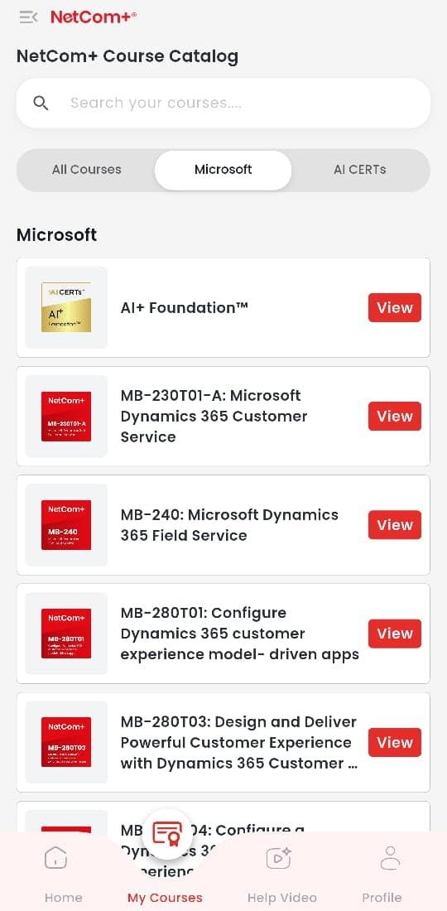

7. Feature/Screen Name: My Courses Screen
Issue Found: MS-4002 and PL-7004 appear under AI Certification instead of Microsoft.
Steps to Reproduce:
- Go to the AI Certification category.
- Check for MS-4002 and PL-7004 courses.
Expected Result: These courses should appear only under Microsoft Certification Courses.
Actual Result: Courses are incorrectly listed under AI Certification.
ScreenShot:
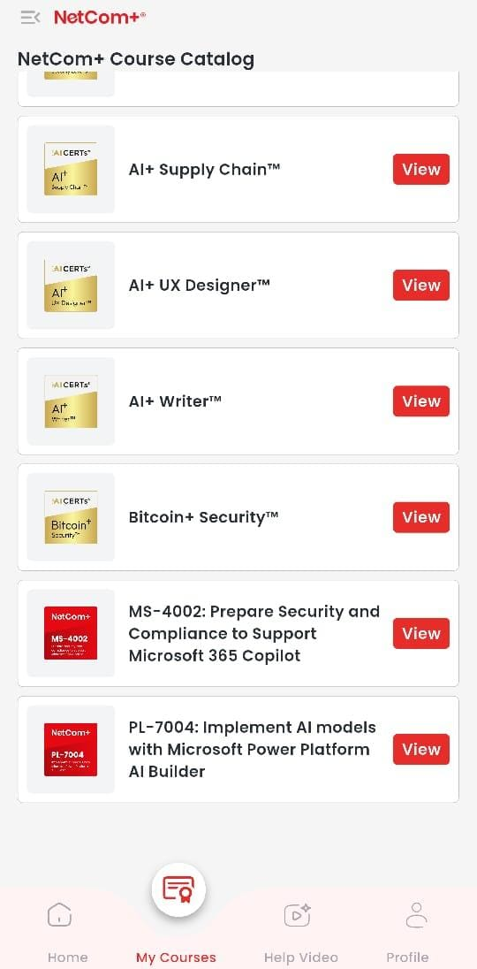

8. Feature/Screen Name: AI Chat – Internet Handling
Issue Found: No offline handling; app hangs without message.
Steps to Reproduce:
- Disconnect from the internet.
- Open AI Chat feature.
Expected Result: A clear “No internet connection. Please check your network.” message should appear, and the chat should resume automatically when the internet is restored.
Actual Result: App freezes without any network error message.
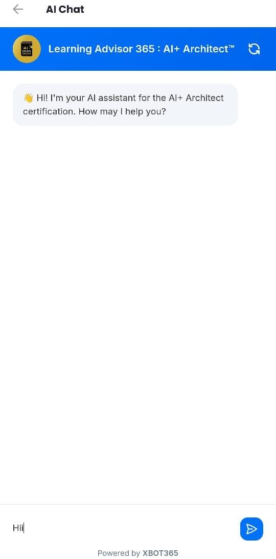
Screenshots:

Improvements And Suggestions:

1. Onboarding Screen – Skip Page Repeating
Improvement:
- Implement a first-launch flag or user session check so onboarding appears only on first use or after reset.
- Store onboarding completion status in local storage or secure storage so it persists even after app restarts.
Suggestion:
- Add an option in Settings to “View Onboarding Again” for users who want a refresher.

2. Radio Button – No Scroll on Touch Outside
Improvement:
- Allow scroll gestures anywhere in the list container, not just over the radio button.
- Adjust touch event handling so it doesn’t block scrolling outside the hit area.
Suggestion:
- Add larger touch zones for radio buttons to improve accessibility on small screens.

3. Contact Support Page – Missing Name & Email Validation
Improvement:
- Add real-time form validation that highlights empty or invalid fields before submission.
- Display clear error messages like “Name is required” or “Enter a valid email”.
Suggestion:
- Use inline validation (error shows immediately after user leaves the field) to reduce failed submissions.

4. Email Validation – Error Message Repeats
Improvement:
- Implement debounce logic so the error only appears once per invalid input.
- Clear the error message as soon as a valid email is entered.
Suggestion:
- Provide a sample email format in a placeholder or tooltip for user guidance.

5. First & Last Name – Accepts Empty or Invalid Characters
Improvement:
- Restrict input to alphabetic characters with optional hyphens/apostrophes.
- Show an inline error if field is left empty or contains invalid characters.
Suggestion:
- Auto-capitalize the first letter of each name for better data consistency.

6. AI + Foundation Course in Wrong Category
Improvement:
- Update backend or CMS category mapping for courses.
- Run a category verification script after each content update.
Suggestion:
- Introduce an admin-side category lock to prevent accidental misplacement in future.

7. Microsoft Courses in AI Certification
Improvement:
- Correct metadata for MS-4002 and PL-7004 so they only appear in Microsoft Certification.
- Perform full category audit to ensure no other courses are misplaced.
Suggestion:
- Add a category filter check in QA before publishing new course listings.

8. AI Chat – Internet Not Handled
Improvement:
- Implement offline detection and show a “No internet connection” message.
- Auto-retry sending messages when the internet connection is restored.
Suggestion:
- Add a retry button so the user can manually resend after reconnecting.

